Project Report of Metis 2020:

Experience in Assembly Game Programming

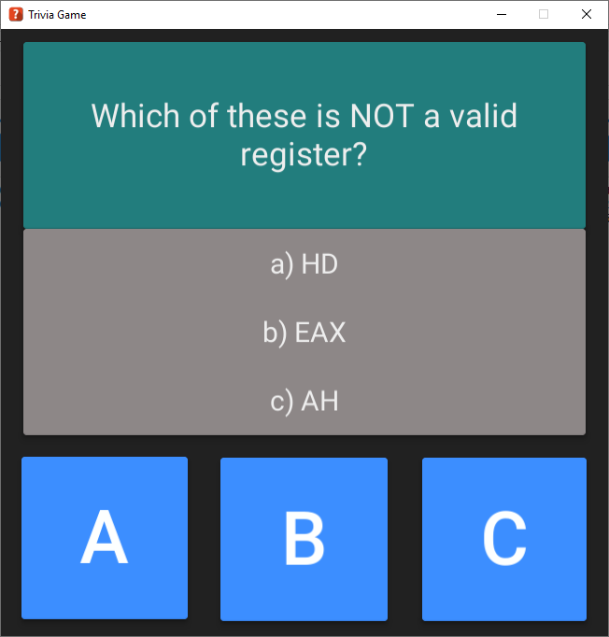

Submitted to:

Dr. John F. Doyle

Associate Professor of Computer Science

Presented by:

Junet Bello, Yiliang Lu, and Amanda Schneider

April 22nd, 2020

Executive Summary

This group project is to design a game and implement it in the Intel x86/x64 Assembly Language. The target audience will be the students and professor of CSCI-C335 Spring 2020 and any interested visitors to the project Github site. The game is named Metis2020. It is inspired by a family game played by one of the project members during the holidays, and it is named for the Greek Goddess of Wisdom. Metis2020 is an interactive, single player, multi-selection trivia game. It has been developed with the Unity frame work using C# and C++ programming languages with in-line Assembly. Utilizing a modern graphical user interface, the players will answer approximately 15 randomly selected questions, which are drawn from five categories of varying difficulty. The members hope to learn, apply, and demonstrate Intel Assembly programming skills obtained during the semester.

## Table of Contents

I. Introduction 1

II. Project Members 1

III. Project objective 2

IV. problems encountered 2

V. Problem solutions 3

VI. FUTURE WORK and conclusion 7

viI. Credits 7

## List of Figures

Figure1**.** List of key personnel 1

Figure 2. The first prototype. 2

Figure 3. C++ calls inline assembly functions 4

Figure 4. called assembly message function 6

Figure 5. called assembly value function 6

Figure 6. Progression of early prototype 6

Figure 7. C++ calls inline assembly functions 4

Figure 8. C++ calls inline assembly functions 4

Figure 9. C++ calls inline assembly functions 4

Figure 10. C++ calls inline assembly functions 4

Figure 11. C++ calls inline assembly functions 4

This page is intentionally left blank.

Introduction

This report is a group project to design a game and implement it in the Intel x86/x64 Assembly language. The target audience will be the students and professor of CSCI-C335 Spring 2020 and any interested visitors to the project Github site. The project members hope to learn, apply, and demonstrate Intel Assembly programming skills obtained during the semester.

The game is named Metis2020. It is inspired by a family game played by one of the project members during the holidays, and it is named for the Greek Goddess of Wisdom. Metis2020 is an interactive, single player, multi-selection trivia game featuring the MIT license. It has been developed with the Unity framework and Visual Studio 2017+ using C# and C++ programming languages with in-line Assembly. Utilizing a modern graphical user interface, the players will answer approximately 15 randomly selected questions, which are drawn from five categories of varying difficulty.

Project Members

The developer of this project are three computer science students of Indiana University Southeast with unique interests and skills.

|  |  |  |  |
| --- | --- | --- | --- |
| Position | Name | Major | Responsibilities |
| Project manager and developer | Bello, Junet | Computer Science | Responsible for adopting and managing the concept into a working product |
| Developer and Designer | Schneider, Amanda | Computer Science | Responsible for incorporating new features to the project |
| Developer and Quality Assurance | Lu, Yiliang | Computer Science | Responsible for documentation, unit testing, and quality control |

Figure 1. List of key personnel responsible for the completion of the project.

Project Objectives

The project members are required to produce a computer game using primarily the Intel Assembly Language. In addition, the members need to present the project to the class audience, produce a written report that detail the implementation, and a “Readme” document that explains the game rules to the end users.

Based on the requirements above, the members have agreed to the following specifications:

* Design a game of single player trivia game
* Determine the primary and secondary communication and collaboration methods
* Create a set of business rules that govern the logic of the game
* Create the game using programming languages to include the Intel x86/x64 Assembly Language, C#, and C++ in Visual Studio 2017+
* Utilize the Unity framework to simplify the development of graphical user interface and input
* Host the project on Github to facilitate group collaboration and source version control
* Share equal divisions of labor: tasks are assigned to each member evenly and
* Control quality: any revisions must be reviewed and approved by another member before the changes are merged to the repository
* Present the project at IUS Student Conference Spring 2020

Problems Encountered

As the projects progressed, the project members have encountered several issues. Some of these issues are addressed in the next paragraph. The last issue has not been fully resolved yet, but the members are seeking assistance from the overseeing faculty member.

1. Understand the scope of the project
2. Determine what and how to deliver
3. Translate more C# methods to ASM functions
4. Balance work and study commitments due to the current of events
5. Determine how to incorporate the assembly code given the Unity framework. The members are still seeking assistance from Dr. Doyle.

Problems Solutions

1. *Understand the scope of the project*

When the project was in the brainstorming phase, group members had some great ideas to include elements of role playing and player interaction with in-game objects such as opening doors. The members quickly realized that they needed to be realistic with what is achievable and not. Given the limited amount of time and competing courses in the semester, the members had to narrow the scope of the project in stay in the realm of practicality.

1. *Determine what and how to deliver*

It took a few weeks to finish the first prototype (Figure 2). While it looks simple, the group members had to invest much time to learn and use Unity, which has a steep learning curve.

The first prototype was created to prove that the project could indeed incorporate Assembly Language in a Unity project. Unity is mostly developed in .NET, and Unity projects cannot access any features that are not supported by the .NET libraries, such direct access to the registers. The framework normally uses scripts to create additional functionalities, but it can also load *plug-ins* or code created outside of Unity. To get around the restrictions, the group wrote a *native plug-in*, which is a platform-specific native code library, to be used with Unity. A native plug-in can directly access features like hardware, OS calls, and third-party code libraries that would otherwise not be available in Unity. In this case, the native plug-in was written in C++ in order to call inline Assembly placeholder functions, which utilized *RAX*  in the following code snippets.

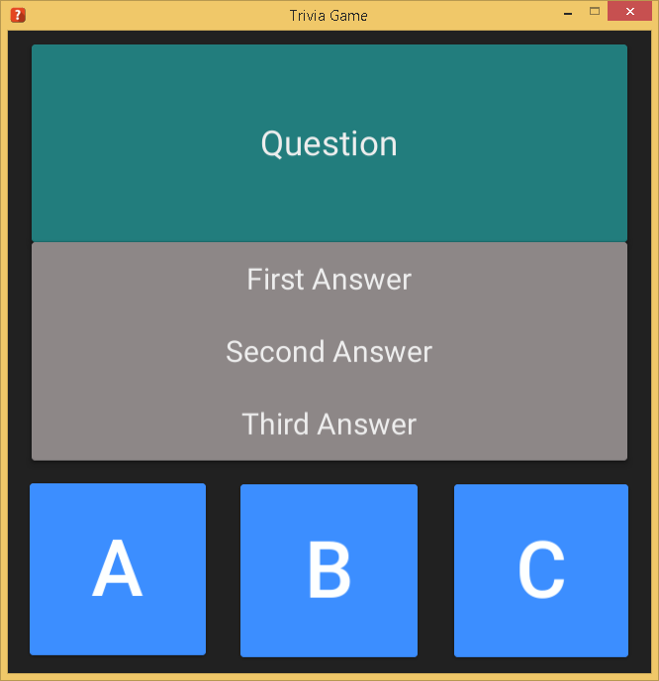

// UnmanagedCode.cpp

#include "pch.h"

#include "UnmanagedCode.h"

extern "C" int GetNumberAsm();

extern "C" char* GetMessageAsm();

int GetTestNumber() {

return GetNumberAsm();

}

char* GetTestMessage() {

return GetMessageAsm();

}

Figure 2. The first prototype.

Figure 3. C++ function that calls inline assembly functions.

; GetNumberAsm.asm

.code

GetNumberAsm proc

mov rax, 100

ret

GetNumberAsm endp

end

## **;GetMessageAsm.asm**

.data

message BYTE "Message from assembly", 0

.code

GetMessageAsm proc

mov rax, offset message

ret

GetMessageAsm endp

end

Figure 5. Placeholder assembly value function.

Figure 4. Placeholder assembly message function.

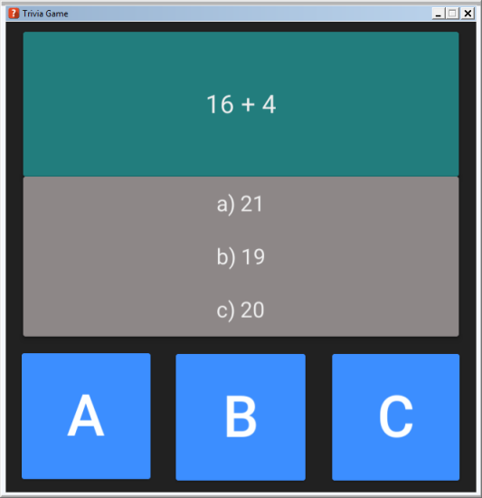

Figure 6. Progression of early prototype.

Recent progress has replaced placeholder questions and answers with the actual questions and answers seen in the third screenshot although they are still hardcoded. The feature to read content through files has not been implemented.

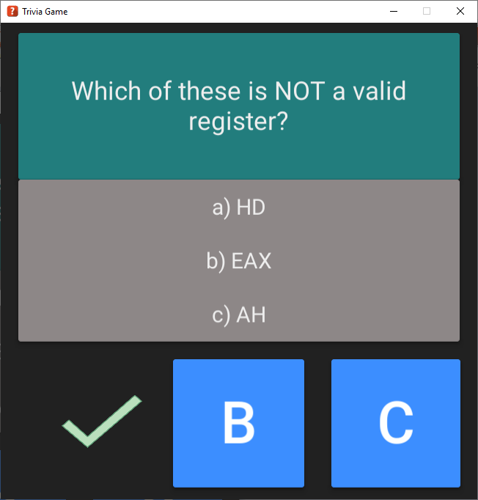

Figure 3. Most recent revision

1. *Translate more C# methods to ASM*

In the early weeks, the majority of the functional code was written in C#, for example:

//Questions are displayed randomly one at a time.  
//Each of the possible answers associated with a question have a button

//assigned to it, and each button has a function that handles the logic to figure //out if the answer is correct or not.

public void UserSelectA()  
 {  
 if (CurrentQuestion.Answers[0].Result)  
 {  
 FirstResponseImg.texture = CorrectTexture;  
 // Add score function. If correct add question score.  
 }  
 else  
 {  
 FirstResponseImg.texture = WrongTexture;  
 // Add score function. If incorrect subtract half of question score.  
 }

Animator.SetTrigger("ButtonAClicked");  
 StartCoroutine(TransitionToNextQuestion());  
 }

public void UserSelectB()  
 {  
 if (CurrentQuestion.Answers[1].Result)  
 {  
 SecondResponseImg.texture = CorrectTexture;  
 // Add score function. If correct add question score.  
 }  
 else  
 {  
 SecondResponseImg.texture = WrongTexture;  
 // Add score function. If incorrect subtract half of question score.  
 }

Animator.SetTrigger("ButtonBClicked");  
StartCoroutine(TransitionToNextQuestion());  
 }

public void UserSelectC()  
 {  
 if (CurrentQuestion.Answers[2].Result)  
 {  
 ThirdResponseImg.texture = CorrectTexture;  
 // Add score function. If correct add question score.  
 }  
 else  
 {  
 ThirdResponseImg.texture = WrongTexture;  
 // Add score function. If incorrect subtract half of question score.  
 }

Animator.SetTrigger("ButtonCClicked");  
StartCoroutine(TransitionToNextQuestion());  
 }

As off 4/5/20, the important methods are still written in C#. Using C#, a DLL generated with C++ gets called, and finally C++ calls Assembly.

For example: The GetTimeInSeconds() method which specifies the time interval between questions to be displayed.

// 1. C# gets triggered on initial load and calls C++ using the imported DLL:

Void Awake()

{

TimeBetweenQuestions = GetTimeInSeconds();

}

// 2. C++ calls Assembly:

int GetTimeInSeconds()

{

return GetTimeInSecondsAsm();

}

// 3. Assembly is where that actual function get executed returning the value needed:

.code

GetTimeInSecondsAsm proc

mov rax, 3

ret

GetTimeInSecondsAsm endp

End

Finally, Assembly returns the value 3 (number of seconds between questions) to C++, which then sends it to C# which communicates with `Unity` to assign the giving value to the next question event.

1. *Balance work and study commitments due to the current of events*

The on-going COVID-19 pandemic has temporarily changed how everyone study and work in the United State. Many people are mostly confined to their homes, and instructions are given remotely. Some may be ill, while some may have to work more or less depends on their profession. Daycares are closed, so families have to manage childcare with other responsibilities.

The members of this project group have also been impacted by the current of events. The disruptions have caused delays and inconveniences, but we are all copping and managing. We are determined to continue the project and meet the goals initially set.

Future Work and Conclusion

The group members had originally envisioned a game with more features. As the project members slowly narrowed scope and focus of the project, some of the wonderful ideas had to be dropped or replaced with practical ones. It is still about two weeks away before the project is due. The interim product is promising and produces correct results. However, the members must stay focused to complete the tasks at hand and complete the final product

After executing the earlier phases of the project, the members already have a much deeper understanding of the Intel assembly language. Everyone has greatly enhanced their skill writing assembly code. The group project will serve an important lesson of time management and project management to all group members. We hope to apply the lessons learned to our future endeavors. May the members succeed and be the next generation of programmers.

Credits

“Unity", Unity logos, and other Unity trademarks are trademarks or registered trademarks of Unity Technologies or its affiliates in the U.S. and elsewhere. Other names or brands are trademarks of their respective owners.